Английский язык 7 класс
18.05.
I. закрепим знание слов прошлого урока через выполнение упражнений:
1. Use the words to complete the text. There are 2 extra words:
acid, sleet, toxic fumes, reduce, air polluters, emit, waste, pollute, acid rain, burning, species, poisons

How does air become polluted?
The main 1) ________ are cars, buses, and planes which 2) ________ smoke and gases into the air. Also factories and plants burn fuels, such as oil and coal, which harm the atmosphere. 3) __________ mix up in the atmosphere making it 4) _________ and later land on grass, trees, and buildings in the form of rain, fog, or 5) _________. We should 6) _________ air pollution that causes acid rains.
How does water become polluted?
Many factories and plants also 7) ________ water by throwing away their 8) __________, which gets into lakes, rivers, and seas and 9) ________ water. It does a lot of harm to different 10) _________ of fish and plants.

2. Use the word given in capitals to form a word that fits each space. (преобразуйте слово, чтобы оно подходило по смыслу предложения, добавив суффиксы)
- Nowadays, one of the global problems is air ___________. (POLLUTE)
- The wind can carry _________ clouds for long distances. (POLLUTE)
- Cars, buses, and planes are all air __________. (POLLUTE)
- Modern technologies can make factory waste less ___________. (HARM)
- __________ energy is an alternative kind of power. (SUN)

II. Познакомимся с новым грамматическим материалом – настоящее совершенное продолженное время Present Perfect Continuous
- прочитать и понять употребление данного времени в грамматическом справочнике учебника с.GR7 (до разделительных вопросов)
have been Ving
has

- посмотреть видео https://www.youtube.com/watch?v=mmegOBtl-_w
- выполнить упражнения:
- Complete the sentences using the verbs in the present perfect continuous tense.
- Tony _______________________ (talk) on the phone for two hours.
- I ____________________________ (look) for my keys since 11 a.m.
- We ______________________________ (wait) for the bus for 20 minutes.
- She ____________________________ (play) computer games for 50 minutes.
- They ____________________________ (live) in Moscow since January.

- Translate the sentences into English.
- Почему он мокрый? – Он стоял под дождем 2 часа.
- Чем ты занималась? – Я работала в саду.
- Почему ты плачешь? – Я полтора часа смотрела свою любимую драму.
- Сдавайте тест! Вы выполняете его уже 40 минут.

- Use the words to make up sentences in the present perfect continuous tense.
- It/snow/all/day ______________________________________________________
- she/work in hospital/since 1999._________________________________________________
- how long/you/have/driving lessons?______________________________________________
- I/learn English/for a long time.__________________________________________________
19.05. – 21.05.
Урок 8 b Тема “Eco-helpers” (помощники природы)
- you will learn about eco-helpers and the equipment they use (познакомимся с помощниками природы и оборудованием, которое они используют).
- you will talk about eco-helpers’ activities (поговорим о их деятельности)

- учебник с. 78 упр. 1 – посмотреть на картинку и составить предложения по образцу,
- упр. 2 – какое оборудование используют дети?
- поучить слова можно здесь https://quizlet.com/496511781/spotlight-7-module-8b-flash-cards/,
- упр. 3 – прочитать диалог, обращая внимание на новые слова, заполнить пропуски в упр. 3b
- посмотреть видеоролик https://resh.edu.ru/subject/lesson/2883/main/ (2 мин.),
- Choose the correct answers to the questions.
- Why is eco-helpers’ voluntary work so important?  - What are eco-helpers’ jobs?  - Why do many young people join eco-helpers clubs? | - They collect rubbish, build nesting boxes, plant trees and flowers and clean out ponds and rivers.  - They do a lot of good to preserve nature.  - They do it because they want to take care about our common home — the planet Earth.
- Match the words with their definitions.
- a volunteer | - a box for birds to nest in
- to recycle | - a person who does services without payment or reward
- rubbish | - to treat sth that has already been used so that it is fit to use again
- a nesting box | - things of no use that are thrown away
- ecology | - to make free from dirt and rubbish
- to clean out | - the relation of plants and living beings to each other and to the environment
- Choose the correct word.
If you want to join our Eco 1) help/helpers/helping club, come to our meeting in Central Park! You will help collect rubbish 2) of/for/in recycling. You can also build 3) nest/nesting/ nests boxes so that many species of birds never 4) left/ leave/leaving our city. We’ll greatly appreciate if you give 5) a help/a hand/an arm cleaning 6) away/out/off the Blue Pond.

21.05.
- you will learn how to offer, accept and refuse help; how to build up tag-questions (узнаем как предложить помощь, принять или отказаться; узнаем как строить разделительные вопросы)
1. Повторить слова прошлого урока
Use the words to complete the text.
• the cycle of life • eco-helpers • ecology • recycling • clean out • volunteers • voluntary • left • nests • pollution • planting • nesting boxes

1) ________collect rubbish in parks and forests for 2) _______ it out of town. They also 3) ________ ponds and rivers. Instructors provide 4) ___________with a lot of useful information. Young eco-helpers read books about 5) __________ and learn about 6) __________.
Volunteers also build 1) _________. It is a very important job as there are not so many trees 2) ________ in big cities for birds to build their own 3) _________. Volunteers learn about the main causes of air and water 4) _________. 5) _________ trees and flowers is also a significant part of their 6) __________ jobs.

2. учебник с. 79 упр. 5 – познакомиться с фразами о том, как предложить помощь, принять или отказаться
Choose the correct answers to the questions.
- Can I give you a hand cleaning out the clubhouse? | - Sure, thanks. We still have about 30 cards left in the office.
- Would you like me to call the recycling centre? | - Sounds great! We need to build some more nesting boxes.
- Do you need some help giving out membership cards? | - Yes, please. And also tidy the eco-library, please.
- Can I help you to buy more wood and nails? | - No, I can manage, thanks.

3. Question tags Разделительный вопрос в английском языке:
- посмотрите видеоурок: (3,5 мин.) https://www.youtube.com/watch?v=C5hNVDk1GT8,
- прочитайте правило составления разделительных вопросов в грамматическом справочнике с.GR7,
- посмотрите на общую формулу составления вопросов данного типа:
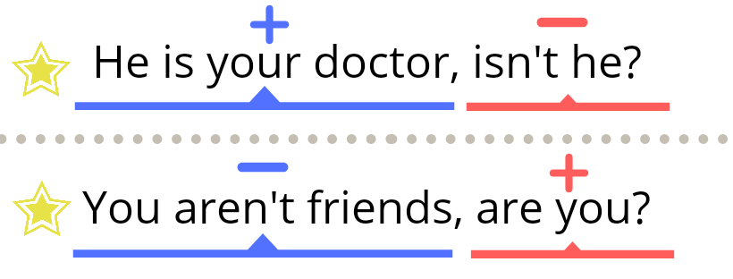
- Составьте вопросы:
1. Tom and Ben are cleaning out the pond, ______? – Tom and Ben are cleaning out the pond,_________?
2. These kids never throw rubbish in the forest, _______? – These kids never throw rubbish in the forest,_________?
3. You can build nesting boxes in spring, _______? – You can build nesting boxes in spring,_________?
4. The eco-helpers have been planting trees for a week already, _______? – The eco-helpers have been planting trees for a week already,__________?
5. The weather was not so good last week, ________? – The weather was not so good last week,_________?
6. We read many books about ecology last month, ________? – We read many books about ecology last month,_________?

4. РТ с. 48 упр. 1, 2а), 3, 4

