Английский язык 5 класс
21.02. Тема: Мой день (My day)
Задачи:
- продолжать работать с новой лексикой по теме «Распорядок дня»;
- учить читать текст, отвечать на вопросы,
- повторить время и предлоги времени at – in.

  - повторите слова по теме «Мой день»:
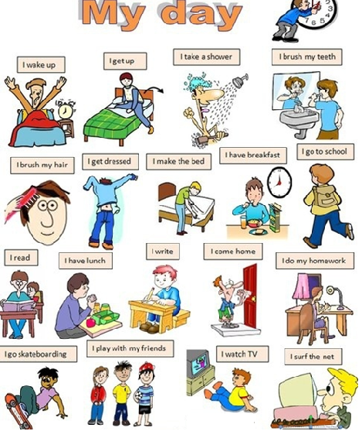

  - прочитайте текст и ответьте на вопросы: Tom’s Daily Routines
I always get up at seven o'clock. Then I eat breakfast. I usually eat bread and drink a glass of milk. Then I feed the cat. I always eat lunch at eleven forty five. At lunch time I usually drink coke and eat a bowl of rice. I usually have dinner at six o'clock in the evening. Later, I do my homework and go to bed. I often go to bed at nine o'clock.
Questions
1.What time does he always get up? _________________________________________________
2. What does he do after that?__________________________________________________________
3. What does he usually eat for breakfast? ________________________________________________
4. What time does he always eat lunch? __________________________________________________
5. What does he usually eat and drink for lunch? ___________________________________________
6. When does he usually have dinner? ___________________________________________________
7. What does he do after dinner? _______________________________________________________
8. What time does he usually go to bed? _________________________________________________

3. Рабочая тетрадь с. 47 выполните упр. 2 и 5.

